YENEPOYA INSTITUTE OF ARTS,
SCIENCE, COMMERCE AND
MANAGEMENT

Project – Low Level Design
on
Hardened Cloud Infrastructure for
Smart City Data

Student Name: Nabil
Register Number : 23BCCE122
Course : BCA in Cloud Computing ,Cyber Security &
Ethical Hacking with IBM

Industry Mentor: Mr. Shashank Guided by: Ms. Vijayalaxmi

1

Table of Contents

Sl.no | Contents | Page
1 | Introduction | 1-2
1.1 | Scope of the document
1.2 | Intended Audience
1.3 | System overview
2 | System Design | 3-9
2.1 | Application Design
2.2 | Process Flow
2.3 | Information Flow
2.4 | Components Design
2.5 | Key Design Considerations
2.6 | API Catalogue
3 | Data Design | 10-11
3.1 | Data Model
3.2 | Data Access Mechanism
3.3 | Data Retention Policies
3.4 | Data Migration
4 | Interfaces | 12 -13
5 | State and Session Management | 14
6 | Caching | 15
7 | Non-Functional Requirements | 16 -17
7.1 | Security Aspects
7.2 | Performance Aspects
8 | References | 18

1. Introduction

The Low Level Design (LLD) of the Secure File Storage System provides a detailed description of the internal working of the application. It focuses on how individual components are implemented, how data flows within the system, and how different modules interact at a code level. Unlike the high-level design, which provides an overview, this document explains the system with more technical depth.
The system is implemented using Python with the Flask framework, where each functionality such as file upload, encryption, decryption, and file handling is handled through specific functions and modules. The LLD helps developers understand how the system is structured internally and how each part contributes to the overall functionality.

1.1 Scope of the Document
This document describes the detailed design of the Secure File Storage System, including module-level implementation, function flow, and data handling mechanisms. It explains how the system processes user requests and performs encryption and decryption operations.

1.2 Intended Audience
This document is intended for developers, system designers, and evaluators who need a deeper understanding of the internal structure and implementation of the system.

1.3 System Overview
The system is a web-based application that allows users to securely encrypt and decrypt files using a password. The user interacts with the system through a web interface, while the backend processes the request using defined modules. The system is designed to be simple, secure, and efficient.

2. System Design

The Secure File Storage System is designed using a modular client-server architecture where the frontend handles user interaction and the backend performs all processing operations. The system ensures separation of concerns by dividing responsibilities into independent modules such as application handling, encryption logic, file management, and logging. This design improves scalability, maintainability, and security of the system

2.1 Application Design
The application design of the Secure File Storage System represents a client-server architecture where the user interacts with the system through a web browser. The user sends requests such as file upload for encryption or decryption through the frontend interface. These requests are forwarded to the Flask backend server, which acts as the core processing unit of the system.

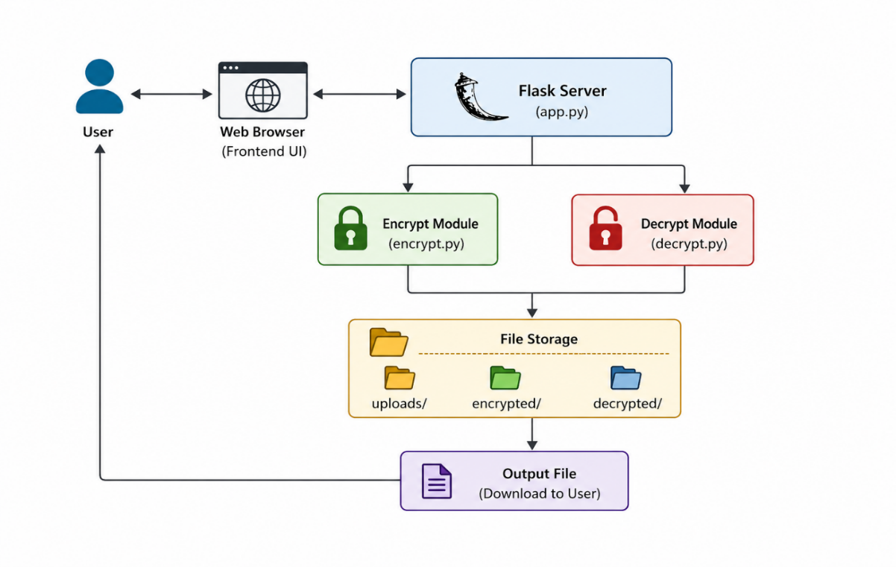

Figure 2.1: Application Design – Secure File Storage System

The Application Design of the Secure File Storage System illustrates a client-server architecture where the user interacts with the system through a web-based interface. The process begins when the user accesses the application using a web browser and performs actions such as uploading a file and entering a password for encryption or decryption.

2.2 Process Flow
The process flow describes the step-by-step execution of encryption and decryption in the Secure File Storage System.
Encryption Process
The encryption process begins when the user uploads a file and provides a password. The system generates a secure cryptographic key from the password using a key derivation function. This key is then used with the AES (Advanced Encryption Standard) algorithm to encrypt the file. After encryption, the file is stored securely in a designated storage folder and the encrypted version is returned to the user.

Decryption Process
In the decryption process, the user uploads the encrypted file along with the same password used during encryption. The system validates the password by regenerating the cryptographic key. If the key is correct, AES decryption is performed to restore the original file. The decrypted file is then returned to the user.

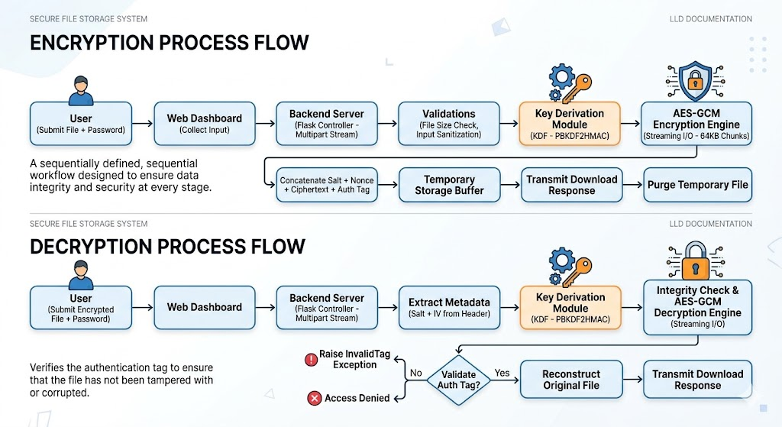

Figure 2.2: Detailed Technical Process Flow Diagram

This diagram breaks down the system operations into two logical flows: Encryption and Decryption, highlighting the technical components and decision logic required to satisfy the “Authenticated Encryption” requirement.

2.3 Information Flow
The information flow within the Secure File Storage System is structured to ensure that sensitive data remains transient, moving through the system as a continuous, encrypted pipeline rather than being persisted as static content. Upon request initiation, raw file data is captured as a multipart stream by the backend, where it is immediately funneled into the cryptographic module for real-time processing. This process avoids long-term disk storage by using temporary, in-memory buffers or short-lived file handles that are purged immediately after the output stream is delivered to the user. This "in-flight" approach effectively eliminates the risk of sensitive data residue, ensuring that the backend serves as a secure, stateless processing conduit that maintains the privacy of the user's information from ingestion to delivery.
Data Lifecycle Stages
Stage | Action | Data State
Ingestion | User uploads file and password via web interface. | Plaintext (In-transit)
Routing | Flask controller validates headers and file size. | Buffer (Temporary)
Transformation | Cryptographic module performs AES-GCM processing. | Encrypted / Decrypted
Delivery | Server streams output to the user's browser. | Streamed (Processed)
Purge | System deletes temporary file handle and memory buffers. | Deleted (Residual-free)

2.4 Components Design
The system is composed of several tightly integrated components that interact to provide a cohesive service. The Controller component is the primary interface for the Flask framework, handling all incoming HTTP methods and managing the user session context for the duration of the request. The Cryptography Engine acts as the heart of the system, housing the logic for key derivation, AES-GCM encryption, and decryption, while remaining completely agnostic of the file storage location. The File Storage component provides a managed interface for writing and reading temporary files, ensuring that all storage operations are abstracted away from the business logic. The Validator component performs security checks on all inputs, such as password strength verification and file integrity checks, acting as the first line of defense against malicious or malformed data. Finally, the Logging component records the operational metadata, such as the timestamp and success status of each encryption or decryption task, to provide an audit trail for system administrators.
System Components Specification
The following table details the specific technical implementation and interface responsibilities for each architectural module.

Component | Responsibility | Technical Interface / Implementation | Dependency
Flask Controller | Request routing, MIME-type validation, and HTTP response handling. | Flask Blueprints, request.files, send_file. | Validator, Crypto Engine

Component | Responsibility | Technical Interface / Implementation | Dependency
Cryptography Engine | Core encryption/decryption logic using AES-GCM and key derivation. | cryptography.hazmat (PBKDF2, AESGCM). | None (Stand-alone)
File Storage Service | Handles read/write operations to disk; manages stream buffers. | os, shutil, tempfile modules. | Crypto Engine
Validator Module | Enforces security policies (password strength, file size limits). | Regex, file_utils, Mime-type checking. | Controller
Logging Service | Records transaction telemetry and error events for auditing. | Python logging library; JSON format. | All Modules

2.5 Key Design Considerations
The design of the Secure File Storage System is governed by a set of foundational principles that prioritize the delicate balance between robust data security and efficient system performance. Security is the paramount design consideration, which led to the selection of the AES-256-GCM cryptographic standard as the core encryption mechanism. This choice was deliberate, as GCM (Galois/Counter Mode) provides both confidentiality and data authenticity, ensuring that the system

can verify the integrity of a file upon decryption and detect unauthorized tampering. Furthermore, the decision to implement high-iteration password hashing using PBKDF2 ensures that the cryptographic keys are resistant to brute-force attacks, adding a critical layer of defense against potential credential-based threats.
Performance is another critical consideration, addressed through the adoption of a memory-efficient streaming architecture. By processing files in fixed-size chunks rather than loading entire binary objects into the server’s RAM, the system ensures that it can handle large file uploads without risking system crashes due to memory exhaustion. This streaming approach also reduces the time to first byte, as encryption or decryption begins as soon as the initial data fragments are received from the user. Statelessness is the final pillar of the system's design, which serves both performance and scalability goals. By ensuring that the server does not retain session state, the system remains lightweight and allows for horizontal scaling, as any server node in a load-balanced environment can process any incoming request without requiring access to a centralized session store. This combination of security, performance, and statelessness creates a robust infrastructure capable of handling confidential information with minimal overhead.

2.6 API Catalogue
The application architecture exposes a specific set of RESTful endpoints to facilitate communication between the front-end dashboard and the back-end processing modules. These endpoints are designed to be intuitive and strictly scoped, ensuring that each route performs a singular, well-defined operation. The communication layer relies on standard HTTP methods, with GET requests used for navigation and state retrieval, and POST requests utilized for data-intensive operations such as encryption and decryption. By adhering to these standard protocols, the API maintains interoperability, allowing the system to potentially

interface with future client applications, such as mobile apps or command-line tools, without requiring changes to the core business logic.
API Interface Definitions
The following table serves as the technical reference for the integration of the user interface with the Flask backend services.
Endpoint | Method | Input | Output | Description
/ | GET | None | HTML Home Page | Serves the primary landing page and system introduction.
/dashboard | GET | None | HTML Dashboard | Renders the operational interface for file management.
/encrypt | POST | File & Password | Encrypted File Stream | Invokes the crypto engine to encrypt the uploaded binary data.
/decrypt | POST | File & Password | Decrypted File Stream | Triggers the integrity-checked decryption of the input file.

This table serves as the technical reference for integrating the user interface with the Flask backend, detailing the routing, request methods, and expected data formats for every system operation. By mapping navigation routes and file-processing endpoints to their respective inputs and outputs, it establishes a clear communication protocol that ensures consistent, predictable interaction between the frontend and the system's core cryptographic modules.

3. Data Design

The data design of the Secure File Storage System prioritizes a zero-knowledge architecture, eliminating the need for persistent relational databases. By treating all information as transient binary streams, the system ensures sensitive data is never stored in plaintext. The design centers on the lifecycle of temporary binary objects, ensuring the backend functions as a secure, ephemeral processing conduit rather than a long-term data repository.

3.1 Data Model
The system relies on a file-based storage model where every encrypted file is structured as a self-contained binary blob. This header-inclusive format encapsulates all cryptographic metadata required for decryption within the file itself, ensuring portability and reducing dependency on external tracking systems.

Offset | Field | Size | Description
0-15 | Salt | 16 Bytes | Random salt used for key derivation.
16-27 | IV / Nonce | 12 Bytes | Initialization Vector for AES-GCM.
28-N | Ciphertext | Variable | The encrypted binary file content.
N+1 | Auth Tag | 16 Bytes | GCM authentication tag for integrity verification.

3.2 Data Access Mechanism
Data access is managed through streaming I/O rather than bulk loading, which keeps the memory footprint minimal regardless of file size. The backend reads binary data in fixed-size 64KB chunks, which are processed by the cryptographic engine and written immediately to the output stream. This streaming architecture abstracts the storage layer, allowing the system to operate independently of the underlying storage medium, provided it supports standard read and write operations.

3.3 Data Retention Policies
The system enforces a strict "ephemeral-first" policy to mitigate data exposure risks. User-uploaded files are assigned a unique transaction ID and stored in a temporary directory. Immediately following the successful transmission of the processed file to the user, the system unlinks the temporary files from the filesystem. No residual data or plaintext passwords are saved, ensuring that the server remains a clean, stateless environment post-transaction.

3.4 Data Migration
The architecture is built for modularity, allowing for future expansion beyond local filesystem storage. While currently optimized for local disk performance, the abstract File Storage component acts as an interface layer. This design allows for a seamless transition to cloud-native object storage (such as AWS S3 or Google Cloud Storage) by simply updating the storage driver, without requiring modifications to the core encryption logic or business flow.

4. Interface

The Interface Design defines the communication contracts between system modules. By enforcing strict boundaries, it keeps the architecture loosely coupled, allowing components like the Cryptography Engine and Storage Service to be updated independently while ensuring data remains secure during transit.
4.1 Interface Specification Summary
Interface Name | Provider | Consumer | Method | Purpose
REST API | Flask Controller | Frontend | HTTP POST/GET | Handles file uploads and downloads.
Validation | Validator | Controller | Boolean | Enforces file type and integrity checks.
Crypto Engine | Crypto Service | Controller | Stream Processing | Performs AES-256-GCM transformation.
Storage Abstraction | Storage Service | Crypto Engine | Binary I/O | Handles local/cloud read/writes.
Audit | Logging Service | All Modules | Async Event Bus | Records operational metadata.

4.2 External Interfaces (REST API)
The external interface acts as a secure, stateless gateway:
- POST /api/v1/encrypt: Accepts a multipart file and passphrase. Validates headers, MIME types, and file size before ingestion.
- POST /api/v1/decrypt: Accepts an encrypted blob and passphrase. Validates cryptographic integrity tags before initiating the decryption stream.
- GET /api/v1/status: A lightweight heartbeat interface for monitoring system availability.
4.3 Internal Architectural Interfaces
Backend modules communicate via standardized method signatures to ensure performance and security:
- Validation Interface: Acts as the system gatekeeper, rejecting malformed inputs or oversized files before they reach sensitive cryptographic processes.
- Cryptography Engine: Uses a streaming interface that processes data in 64KB chunks. The signature process_stream(input, key, mode) allows for large file handling without memory exhaustion.
- File Storage Abstraction: Uses generic read_chunk() and write_chunk() methods. This abstracts the storage layer, allowing the system to switch from local disk to cloud storage without modifying the encryption logic.
- Error Propagation: Prevents information disclosure by mapping all internal failures (e.g., IntegrityError) to generic, sanitized HTTP error codes (e.g., 400 Bad Request), ensuring no technical system data is leaked.

5. State and Session Management

The Secure File Storage System utilizes a purely stateless architecture, meaning no server-side state is maintained across requests. By eliminating the use of server-side sessions, cookies, or database-backed storage, the system ensures that every incoming HTTP request is treated as an isolated, self-contained transaction. The client-provided credentials and file data are processed in real-time, and the server discards all operational context immediately upon the completion of the response.

This architecture significantly enhances system scalability. Because there is no dependency on a centralized session store, the application can be deployed across a cluster of load-balanced server nodes without requiring sticky sessions or complex session replication. Any server instance in the cluster can handle any incoming request, providing seamless horizontal scaling and high availability. This design ensures that every interaction is atomic; the system does not need to manage session lifecycles, timeouts, or backend synchronization, which drastically reduces the system's operational overhead.

Furthermore, this approach minimizes the system's attack surface. Without long-lived session identifiers, the system is inherently protected against common vulnerabilities such as session fixation, session hijacking, and cross-site request forgery (CSRF). Because the server does not retain user-specific data or history, the system also naturally complies with strict data privacy and minimization requirements. The ephemeral nature of these transactions ensures that no residual session data exists to be compromised, maintaining total isolation between concurrent users and simplifying the overall architecture.

6. Caching

The caching strategy adheres to a "Security-First" mandate, prioritizing data confidentiality over performance. Caching of encrypted or decrypted binary data is strictly prohibited to prevent unauthorized data recovery from client devices, server-side memory buffers, or intermediate network nodes.
To ensure no sensitive data persists, all API responses delivering file streams include strict Cache-Control headers, specifically no-store, no-cache, and must-revalidate. This forces the client browser to purge binary data immediately upon completion of the request, preventing residual storage on local disk or memory.
On the server side, the stateless architecture forbids the use of memory caches like Redis or Memcached for file streams to mitigate the risk of memory-scraping attacks. Furthermore, the system mandates that all intermediate agents—including load balancers, reverse proxies, and Content Delivery Networks—treat sensitive traffic as private and non-cacheable. This prevents encrypted blobs from residing in edge caches, ensuring the data lifecycle remains fully controlled even if external network infrastructure is compromised.
To maintain interface responsiveness without compromising security, the application maintains a rigid architectural separation between the file-processing pipeline and the user interface. While core operations are governed by strict no-cache rules, non-sensitive static assets—such as cascading style sheets, JavaScript bundles, and graphical UI elements—are permitted to be cached. These resources are served via isolated, read-only endpoints that are strictly decoupled from the cryptographic engine, ensuring that caching policies for UI components cannot inadvertently expose sensitive data.

7. Non-Functional Requirements

These requirements define the essential operational qualities of the Secure File Storage System, ensuring that the architecture remains robust, secure, and performant under production conditions.
7.1 Security Aspects
Security serves as the foundational constraint for all system operations. The primary mandate is the absolute protection of data confidentiality and integrity through a defense-in-depth approach.
- Confidentiality and Integrity: All file operations must utilize AES-256-GCM authenticated encryption. This ensures that data is encrypted while at rest and that any unauthorized modification to the file—even by a single bit—results in a failed integrity check during decryption. Plaintext data must never be written to persistent disk storage or transmitted over unencrypted network channels.
- Zero-Knowledge Architecture: The system must strictly adhere to a zero-knowledge model. No user passwords, cryptographic keys, or unencrypted file contents are to be stored in persistent databases or logs. All sensitive material is handled in transient memory and immediately purged upon the completion of the transaction.
- Information Disclosure Prevention: To mitigate the risk of reconnaissance attacks, the system must employ generic error handling. Regardless of the internal error source—whether a cryptographic mismatch, file system access issue, or validation failure—the client must receive sanitized, non-descriptive error messages. Detailed diagnostic information is reserved exclusively for secure, internal administrative logs.

7.2 Performance Aspects
The performance strategy focuses on high-efficiency processing and horizontal scalability, ensuring the system can handle significant workloads without compromising its security-first posture.
- Resource-Efficient Processing: The system must be capable of processing file streams up to 100MB per transaction. To prevent server-side memory exhaustion, all file operations must utilize chunked binary I/O. By streaming data in fixed-size buffers rather than loading entire files into RAM, the memory footprint remains constant and stable, regardless of the total file size.
- Latency and Responsiveness: The system is engineered to provide a seamless user experience, with a target Time-to-First-Byte (TTFB) of less than 500ms for file processing operations under standard load. This is achieved by minimizing the overhead in the cryptographic pipeline and ensuring that the internal interface calls are non-blocking.
- Horizontal Scalability: The system must be fully stateless to support elastic horizontal scaling. By eliminating dependency on sticky sessions or shared state, the application can be deployed across a cluster of load-balanced container instances. This allows the system to scale compute resources dynamically based on real-time traffic volume, ensuring high availability and resiliency without architectural modification.

8. References

The Secure File Storage System leverages industry-standard frameworks and security protocols to ensure reliability and data integrity.
- Technology Stack: The backend is built using the Flask (Python) framework for efficient HTTP request handling and business logic. The frontend is developed using HTML/CSS to provide a secure and user-friendly interface.
- Cryptographic Implementation: Security operations utilize Python’s robust Cryptography libraries, adhering to standard encryption algorithms (AES) to maintain data confidentiality.
- Development Standards: The system design integrates standard Python file handling mechanisms and security best practices to manage data streams safely. Implementation is guided by official documentation and established security guidelines to ensure the correctness and resilience of the architecture.

- • Flask Documentation – https://flask.palletsprojects.com/
- • Python Official Documentation – https://docs.python.org/3/
- • Cryptography Library Documentation – https://cryptography.io/
- • MDN Web Docs (HTML & CSS) – https://developer.mozilla.org/
- • NIST Security Guidelines (Data Encryption Standards) – https://csrc.nist.gov/

